**19 Sept 2014** **The Weekly Bulletin of Rotary Club of Kathmandu Mid-Town** **bc-12/9.014**

|  |
| --- |
|  |

District: 3292 Web:www.rotarymidtown.org.np Club Id: 26776

**SEPTEMBER IS NEW GENERATIONS MONTH**

**Celebrating**

**25 Years in Rotary**





Friday, 12 September : Extracts of the Minutes # 1246

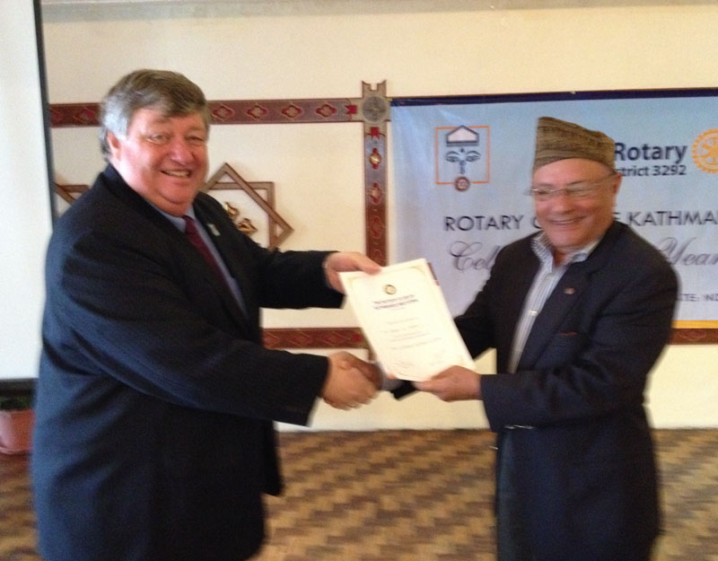

Acting President Peter handing over a

certificate of appreciation to Dr Bhekh.

“ Acting President Peter spoke briefly about the Guest Speaker Bhekh B

Thapa before Rtn Sangita formally introduced the Guest Speaker.

Mr Thapa has served as Secretary of Ministry of Finance, Governor of Nepal

Rastra Bank, Ambassador to India & USA and Foreign Minister & Finance

Minister.

“ Mr. Bhekh B Thapa at the beginning talked about his approach with

golf and how he hit his first golf ball. He talked at length about the land

reforms in Nepal highlighting the historical perspective. He said it was

King Mahendra’s first initiative with regards to land reforms in Nepal. He

said it was a landmark reform in the context of Nepal as for the first time in

the history of Nepal, land reform was implemented in 1964. He also said

that the breakdown of land has minimized commercial farming and the

economy of scale.

“ Rtn Sanjib, Rtn Govinda, PP Giri took part in the discussion. Rtn Sanjib gave vote of thanks to Mr. Thapa .”

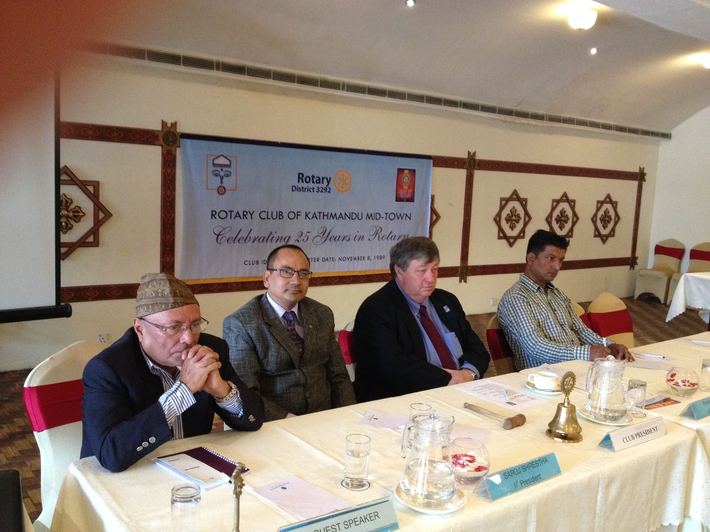

Guest Speaker Dr Bhekh B Thapa listening to questions/comments raised from the floor after his presentation.

Information Sharing:

- “ PP Ambika informed the Club that her son in law Rtn Remy Einhaus will be in Nepal around second half of September and he was looking for updates on the Bio Gas Project.

- “ PP Mani informed the club that due to some technicalities it has become difficult to reimburse around NPR 190,000/- from the government for purchase of materials required for Matching Grant Sheer Memorial Hospital Project.

- “Members present: 30”

# Weekly Meetings and Programs :

|  |  |  |
| --- | --- | --- |
| Date | Program/Speaker | Program/Topics of Presentation |
| 19 September | Prof Dr Pitamber Sharma | Unravelling the mosaic and its implications for federalization |
| 26 September | CAS Gaurav Shamsher Rana |  |
|  |  |  |
|  |  |  |

Friday, 19 September

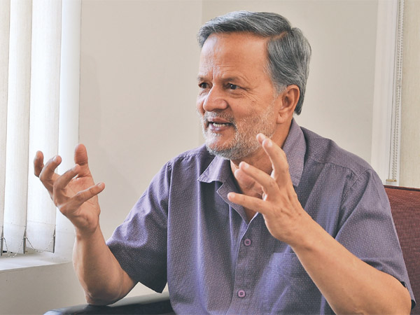

Prof Pitamber Sharma is our guest speaker. He will give a brief talk on

unraveling the mosaic and its implications for federalization.

Guest Speaker Pitamber Sharma is Geographer/Regional Planner, and

Independent Consultant in varied fields. He is associated with Social Science

Baha/Himal Books, Kathmandu.

Dr. Pitamber headed National Planning Commission for a short period in

2008 as Vice-Chair. Before that he worked as Regional Planner in ICIMOD

for over a decade from 1989 to 2000. He was Chief Advisor to National

Commission on Population/HMG during a period 1981-1984.

After completing his MSc from University of Edinburgh, Scotland in 1971

he joined Tribhuban University in 1972 as Lecturer in Geography faculty and

continued in the faculty as Reader and then as Professor until 1998.

He earned his Doctor of Philosophy (PhD) from Cornell University, Ithaca, New York, USA in 1979 in Development Economics/Sociology with Urban and Regional Planning as Major field of Studies. He did his MA in Geography from Tribhuvan University in 1967.

Dr Pitamber Sharma has many books and over 40 research papers, articles and reviews in national and international publications to his credit.

Falebas Khanigaon of Parbat District is his native village.

**World First Aid Day:13 September**

Second Saturday in September every year : Raising awareness of how first aid can save lives.

On 24 June 1859, Henry Dunant, a young Geneva businessman,

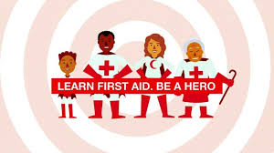

witnessed horrifying suffering and agony following the battle of

Solferino in northern Italy which sparked the idea of first aid that

has since changed the world.

The International Federation of Red Cross and Red Crescent Societies

(IFRC) introduced World First Aid Day in 2000. Each year, more than

100 Red Cross and Red Crescent Societies around the world organise

events and ceremonies to raise public awareness of how first aid can

save lives in every day crisis situations. First aid is a humanitarian act

that should be accessible to all - including the most vulnerable, and

should also be an integral part of a wider developmental approach.

With first aid skills volunteers and communities are empowered to

save lives without discrimination. Taking immediate action and

applying the appropriate techniques, while waiting for professional help,

can considerably reduce deaths and injuries, and the impact of disasters

and everyday emergencies. First aid is not a replacement for emergency services. It is a vital initial step for providing effective and swift action that helps to reduce serious injuries and improve the chances of survival.

First aid awareness is lacking in many vulnerable communities, where a very basic idea of how to treat an injury or keep someone alive, would have real impact. Most important is the fact that first aid reduces vulnerabilities and helps build stronger communities.

World First Aid Day is the perfect opportunity to organise a training event for your workplace. By equipping your staff with skills that could possibly save a life, you are not only investing in a safe and healthy workforce, but are also contributing to a local community that is able to react to emergency situations..

*Source: Internet News*

**Children’s Day:14 September**

Children's Day is recognized on various days in many countries around the world, to honor

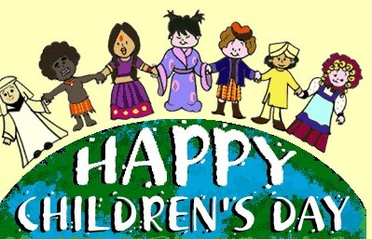

[children](http://en.wikipedia.org/wiki/Children) globally. It was first proclaimed by the World Conference for the Well-being of

Children in 1925 and then established universally by the United Nations General Assembly

in 1954 to encourage all countries to institute a day, firstly to promote mutual exchange

and understanding among children and secondly to initiate action to benefit and promote

the welfare of children around the world.

In September 2012 Secretary-General [Ban Ki-moon](http://en.wikipedia.org/wiki/Ban_Ki-moon) of the United Nations led the initiative

for the education of children. He firstly wants every child to be able to attend school, a goal

by 2015.  Secondly, to improve the skill set acquired in these schools. Thirdly,implementing policies regarding education to promote peace, respect and environmental concern.

In Nepal Children's Day (Baal Diwas) is celebrated on Bhadra 29 (14 Sept). Children’s Day

is observed on the day when Nepal signed and approved the protocol passed by UN Convention on Child Rights in September 1990 (29 Bhadra). Nepal Children’s Organization and Bal Mandir organize various programmes throughout the country on that day.

*Source: Internet News*

**International Day of Democracy: 15 September**

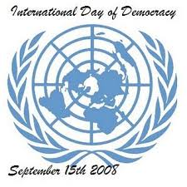

Democracy is a universal value based on the freely expressed will of people to

determine their own political, economic, social and cultural systems and their full

participation in all aspects of their lives.

While democracies share common features, there is no single model of democracy.

In 2007 the [United Nations General Assembly](http://en.wikipedia.org/wiki/United_Nations_General_Assembly) resolved to observe 15 September as

the International Day of Democracy—with the purpose of promoting and upholding

the principles of [democracy](http://en.wikipedia.org/wiki/Democracy)—and invited all member states and organizations to

commemorate the day in an appropriate manner that contributes to raising public

awareness.

This year's theme - **Engaging Young People on Democracy** - highlights the

challenges and opportunities of young people engaging in democratic processes.

People between the ages of 15 and 25 constitute a fifth of the world’s population. In many developing countries, the proportion is even higher – with the majority of young people today living in low - and middle-income countries.

The [Inter-Parliamentary Union](http://www.ipu.org/idd) is promoting the International Day of Democracy through its Member Parliaments in 162 countries around the world

*Source: Internet News*

**International Day for the Preservation of the Ozone Layer: 16 September**

On December 19, 1994 the UN General Assembly proclaimed 16 Sept

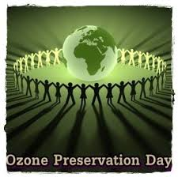

the International Day for the Preservation of the Ozone Layer,

commemorating the date of the signing, in 1987, of the Montreal Protocol

on Substances that Deplete the Ozone Layer. The day was first

celebrated on 16 September 1995.

States were invited to devote the Day to promote activities in accordance

with the objectives of the Protocol and its amendments. The ozone layer, a

fragile shield of gas, protects the Earth from the harmful portion of the rays

of the sun, thus helping preserve life on the planet.

The theme for this year’s celebration is “Ozone Layer Protection: The

Mission Goes On”.

The Montreal Protocol has so far been successful in meeting some of its targets on phasing out ozone-

depleting substances. As a result, the abundance of ozone-depleting

substances in the atmosphere is declining and the ozone layer is expected

to recover around the middle of this century.

On this day primary and secondary school educators throughout the world organize classroom activities that focus on topics related to the ozone layer, climate change and ozone depletion. Other activities that are organized by different community groups, individuals, schools and local organizations across the world include: the promotion of ozone friendly products; special programs and events on saving the ozone layer; the distribution of the UNEP's public awareness posters to be used on the Day.

. *Source: Internet News*

**Biswokarma Puja: 17 September**

Bishwakarma is regarded as the main craftsman and architect of Gods. Biswakarma is son of Lord Brahma, the creator of the whole universe.  Biswakarma is  the official builder of all the gods' palaces. As per Hindu mythologies Biswakarma is the designer of all the flying chariots of the gods and goddesses.

Biswakarma puja is regarded as “a resolution time for workers and craftsmen to increase productivity and gain divine inspiration for creating novel products”. It is a pooja of Lord of art, architecture or engineering. It is a worship and tribute to all those who invented the technology. It is salutation to all who worked in the field of physics for the betterment of people.

Hindus widely regard Biswakarma as the god of architecture and engineering.  The celebration generally is done within the factory premises or shop floor, office or workshops. All the machineries are worshiped along with the worship of Biswakarma.  Picture of Biswakarma is taken out in procession in many part of Nepal after the pooja is over. People install picture of lord Biswakarma at the corners of cross roads. Puja is also associated with the custom of flying kites. This occasion in a way also marks the start of the festive season that lasts till Tihari.

*Source:* Internet News

**Committee Chairs’ Column:** *(This column is for use by chairpersons of 5 permanent committees: Club Administration, Membership, Public Relations, Service Projects, and the Rotary Foundation)*

From the Club Administration’s information desk:

"Changa Chait" an annual Dasain event has been scheduled on Saturday, 27 Sept.  Rtn Navyo has, yet again, kindly offered his house as the venue.  It is a wonderful location for the event.  Let us all gather again this year and make the program lively, interesting and enjoying.

Program: Kite flying; Day/Date: Saturday, 27 Sept; Time: 2 PM

Venue: Rtn Navyo’s house, Tallo Dakshi, Macchegaun VDC-8;

Tel:  [**016916359**](tel:%2B%2B977%20-%20016916359)**;** Mobile: [**9851044374**](tel:%2B%2B977%20-%209851044374)

On Lighter Side :



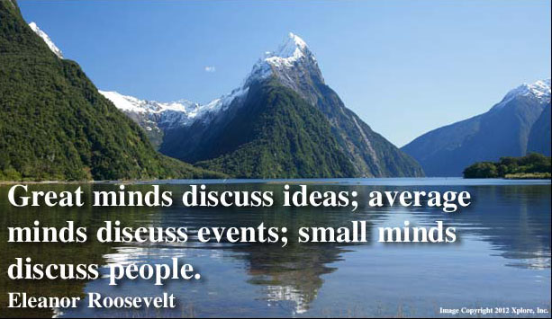

Great Quotes:

**[To love is nothing, to be loved is something,](http://www.brainyquote.com/quotes/quotes/a/albertcamu100779.html" \o "view quote)**

**[but to love and to be loved by the one you love,](http://www.brainyquote.com/quotes/quotes/a/albertcamu100779.html" \o "view quote)**

**[that is Everything.](http://www.brainyquote.com/quotes/quotes/a/albertcamu100779.html" \o "view quote)**

**[Never take love for granted.](http://www.brainyquote.com/quotes/quotes/a/albertcamu100779.html" \o "view quote)**

**Members’ Corner:** *(This column is for Club members to express anything they would like in matter of Club activities, Club administration, Club issues or on Breakfast Chatter, or on anything else that would be of interest to fellow members.)*

President Kul comments on last week’s BC (# bc-11/9.014):

“On remarks by speaker from UNHCR - a small point - it cannot be true that 30 million refugees are on account of the Syria crisis. I would guess that at it would be at most 3 million.”

When I see the work Rotarians do, I am always impressed, always excited, and

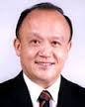

always inspired. When I see the work of our New Generations, I am all of this – and

frequently I am surprised as well. Not by the quality of their work – for I have

learned to expect great things from them – but by the creativity and ingenuity of

their thinking. I look at what they have done and think not just "What a great job!"

but "What a great idea!"  .

**RI President GARY C.K. HUANG**

Please send information on club activities, progress reviews on service projects, relevant photos etc to:

BC Editor: RR Shrestha email: rryesrr@gmail.com

## 19 September 2014 The Weekly Bulletin of Rotary Club of Kathmandu Mid-Town bc-12/9.014